Q3)Explore packet filters using TCP-dump,Wireshark,Cisco Packet Tracer

1)Wireshark:

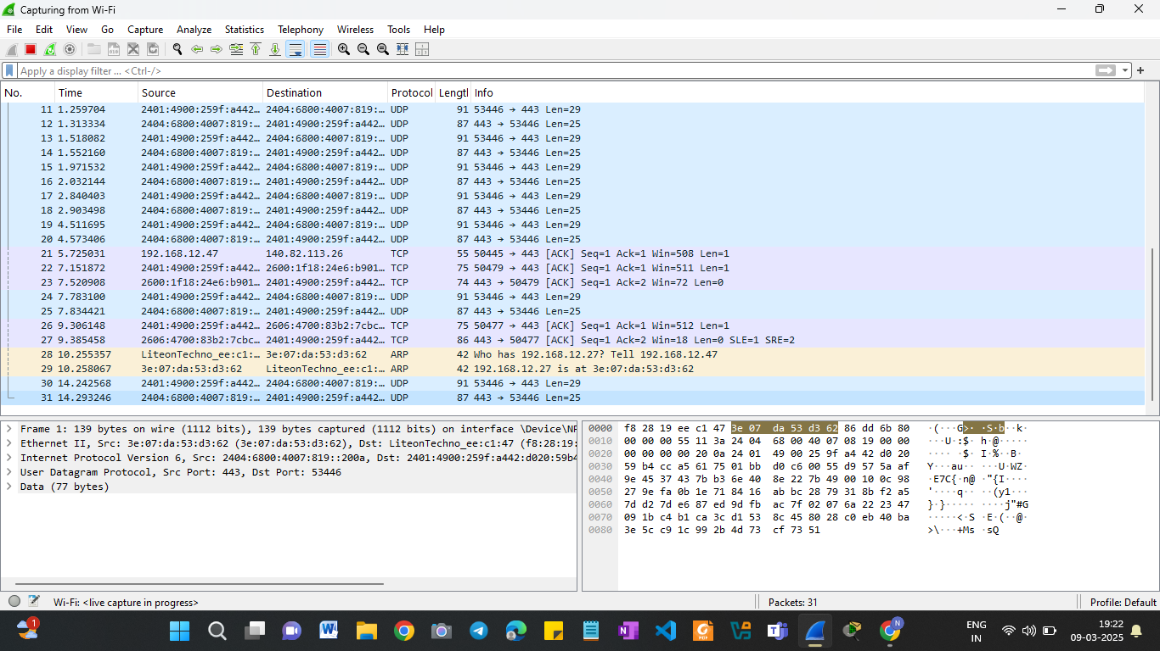  
Using Options:

1. http || tls

• http → Shows unencrypted HTTP requests.

• tls → Shows encrypted HTTPS traffic.

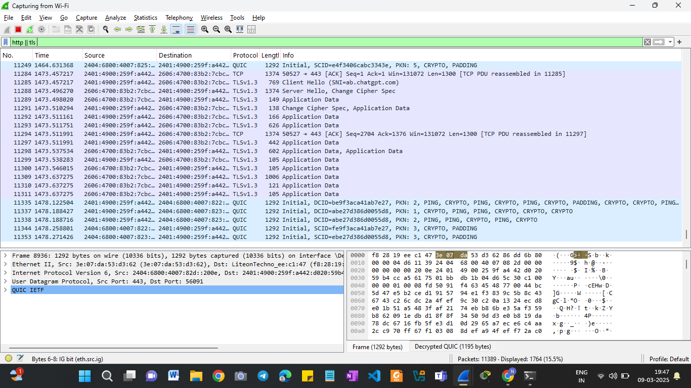

1. tcp: To show only TCP packets

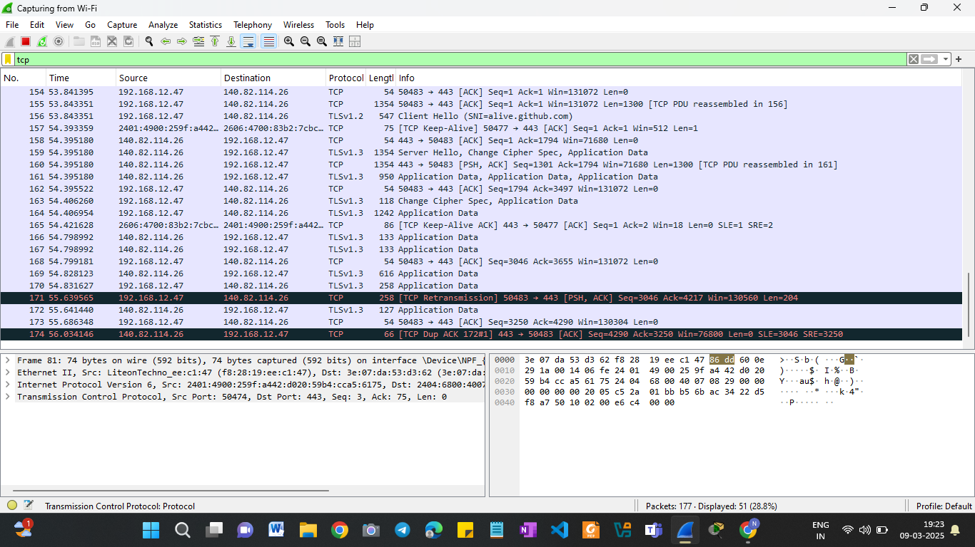

1. icmp: show only ICMP packets (ping requests)

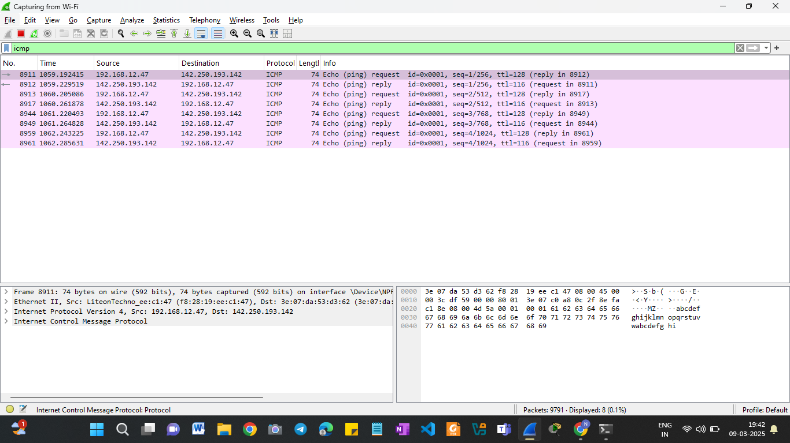

2)TCP –dump:

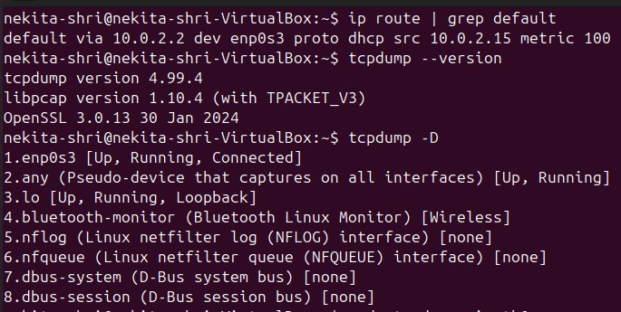

3)Cisco Packet Tracer :

* Simple P2P network:  
  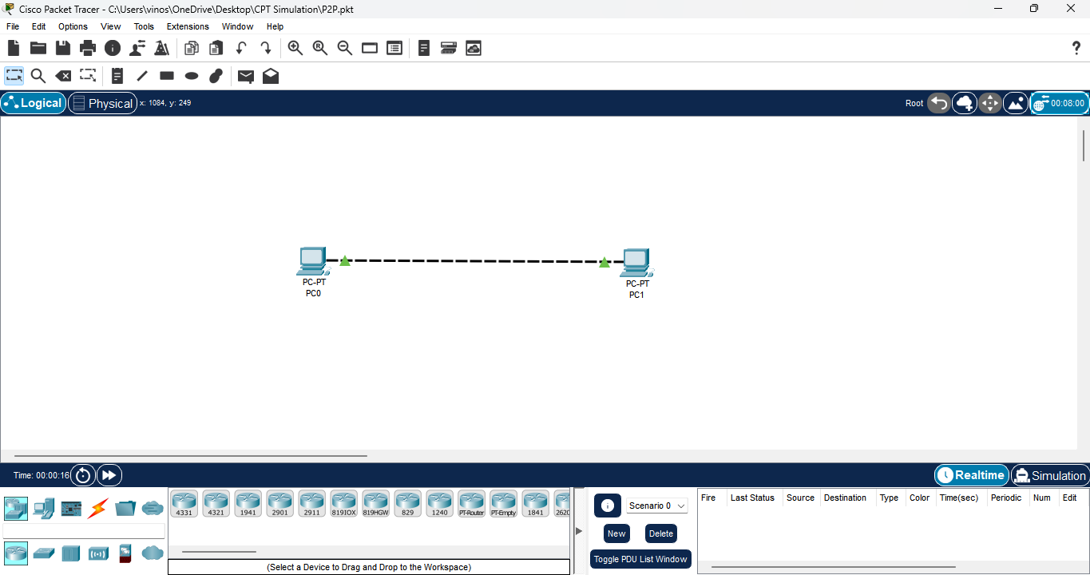
* Use of HUB:

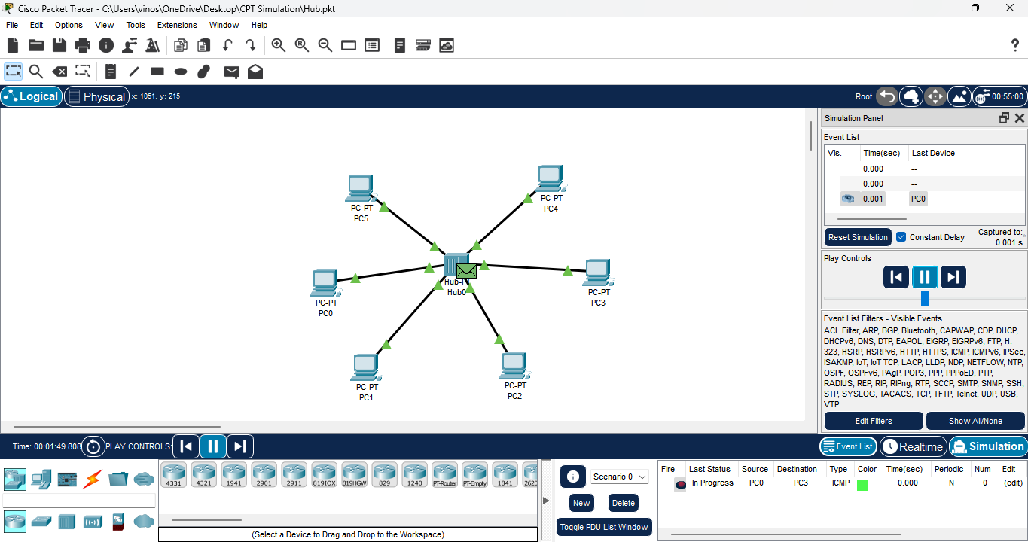

* Use of Router

